**Working process of the N tracking program:**

1. A user inputs the GPS location (latitude and longitude) of the field from online Illinois map (on a computer or a smart phone app), field and management information;
2. According to the GPS location, the program will read the weather database and generate a specific weather data file for DSSAT to use. The weather data file will contain the actual weather information at the location from the date of planting or known initial condition date (before the planting date) to the current date, and averaged weather data from the current date to a default harvesting date (better in the middle of November);
3. According to the GPS location, the program will read the soil database and generate a specific soil data file for DSSAT to use;
4. Based on the user input management information, the program will generate a specific experimental file (FileX) for DSSAT to use;
5. Check if the corn cultivar is new or not. If new, determine the cultivar physiological parameters and add the parameter file;
6. Run DSSAT in Command line mode, an output file with the extension name .OSN will be generated, which will contain ammonium and nitrate concentrations in different soil layers on each day from the initial day or planting day (whichever is earlier) to the default harvesting day;
7. The program will read the output data of each day from the output file, and show the results from the planting day to the current day, the data after the current day will be discarded.

**Ask a user to input:**

Corn field location: latitude and longitude in degree. Example: lat = 40.084; long = -88.240

Planting date: mm/dd/yyyy. Example: 04/23/2015

Corn cultivar: Name and the relative maturity index in days (RMI). Example: DKC 62-08 RIB, 112

N application history: date, rate and placement depth. Example: 11/13/2014, 100 lbs N/acre, 20 cm; 04/23/2015, 50 lbs N/acre, on surface; 05/28/2015, 50 lbs N/acre, 15 cm.

**Obtain the weather information and generate a weather file:**

Go to c([\\swsrsetserver](\\\\swsrsetserver))\2015Data\NWS\2015\ to search and read the weather data. For example, the weather data on 1/13/2015 are saved in the file “c([\\swsrsetserver](\\\\swsrsetserver))\2015Data\NWS\2015\01\13\2015-01-13-IL.CSV”.

The columns in the file are:

Column 1: Year

Column 2: Day of the Year

Column 3: Latitude, degree

Column 4: Longitude (East), degree.

This needs to be converted to West, i.e. Long(West) = Long(East) - 360

Column 5: Elevation, m

Column 6: Air temperature minimum, °C

Column 7: Air temperature maximum, °C

Column 8: Average dew point temperature, °C

Column 9: Average wind speed, m/s

Column 10: Average wind direction, degree

Column 11: Precipitation, kg/m2, or mm

Column 12: Sky cover, %

Column 13: Solar radiation, MJ/m2/day

To find the record for the field location, we need to find the distance between the user input location and the record location:

$$d=\sqrt{{(Latitude-lat)}^{2}+{(Long(West)-long)}^{2}}$$

The data of the record with the minimum *d* will be used as the weather data at the location. Once the record location on a date is determined, all the records on other dates have the same location. Therefore, it is better to code each record in each day’s data. When read the weather data on a different day, we can directly go to the location and read it and do not need to search the location again.

After each day’s data are read, we will need to write a specific weather dada file for this location. The weather data file format is defined in file: h([\\swsrsetserver](\\\\swsrsetserver))\N Tracking Project\Weather Data\WEATHER DATA file format. It is recommended to name the weather data file as *UINT*xx*01.WTH*, where “xx” represent the cropping year. For example, “xx” can be 16 for year 2016. The generated weather data file should be saved in C:\DSSAT46\Weather. An example of the weather data file is C:\DSSAT46\Weather\UICP1501.WTH.

**Obtain the soil information and generate a soil file:**

The soil information is stored in h([\\swsrsetserver](\\\\swsrsetserver))\ N Tracking Project\Soil Data\IL_Soil_Data_Base_Das.txt. The explanation of each column in the file is descripted on the last two pages in h([\\swsrsetserver](\\\\swsrsetserver))\N Tracking Project\Soil Data\ IL Soil Data Extraction from gSSURGO.docx.

Similar to the weather data, we also use the minimum distance between the user input location and the record location to identify the soil data record for the field location,

$$d=\sqrt{{(Latitude-lat)}^{2}+{(Long(West)-long)}^{2}}$$

After locating the record, read this record, and then write a new soil data file specifically for the field’s simulation. C:\DSSAT46\Soil\UI.SOL is an example of the generated soil file. The soil data format and description can be found in h([\\swsrsetserver](\\\\swsrsetserver))\N Tracking Project\Soil Data\ Champaign soil data sample.xlsx. It is recommended to name the soil data file as “UI.SOL”, and to replace the sample file in C:\DSSAT46\Soil.

**Generate a simulation file:**

All the data of the field and management information should be written to a simulation file (DSSAT calls it as FileX, Crop Management File or Experiment File). The file format is explained in h([\\swsrsetserver](\\\\swsrsetserver))\N Tracking Project\FileX format.docx. An example of a FileX is C:\DSSAT46\Maize\UICP1501.MZX. It is recommended to save the file in C:\DSSAT46\Maize.

**Parameters of corn cultivar:**

In the DSSAT system for Maize simulations, there are three files holding the morphological and physiological parameters of corn cultivars: MZCER046.SPE, MZCER046.CUL, and MZCER046.ECO, all of which are located in C:\DSSAT46\Genotype. For a specific corn cultivar, we only need to deal with “MZCER046.CUL” for simulating corn production of our purpose. It is very possible that the corn cultivar input by a user is not listed in the cultivar list of the original file. For example, “DKC 62-08 RIB” was not in the file. I added a record “NT0001 DKC 62-08 RIB . IB0001 228.0 0.500 742.0 750.0 9.00 49.00” to the list (Line 52). We may search the list first to see if the user input cultivar is in the list or not. If yes, then we don’t need to add a new record. If not, we need to generate a record as I added to the list. In this “not” case, it is required for the user to input the relative maturity index in days (RMI) of the corn cultivar. With the RMI, we may estimate the cultivar coefficients as:

$$P1=4.0×\left(RMI\right)-220$$

$$P2=0.5$$

$$P5=6.0×\left(RMI\right)+70$$

$$G2=750$$

$$G3=9$$

$$PHINT=49$$

Then add the record to the file “MZCER046.CUL” with the cultivar’s name as the user input.

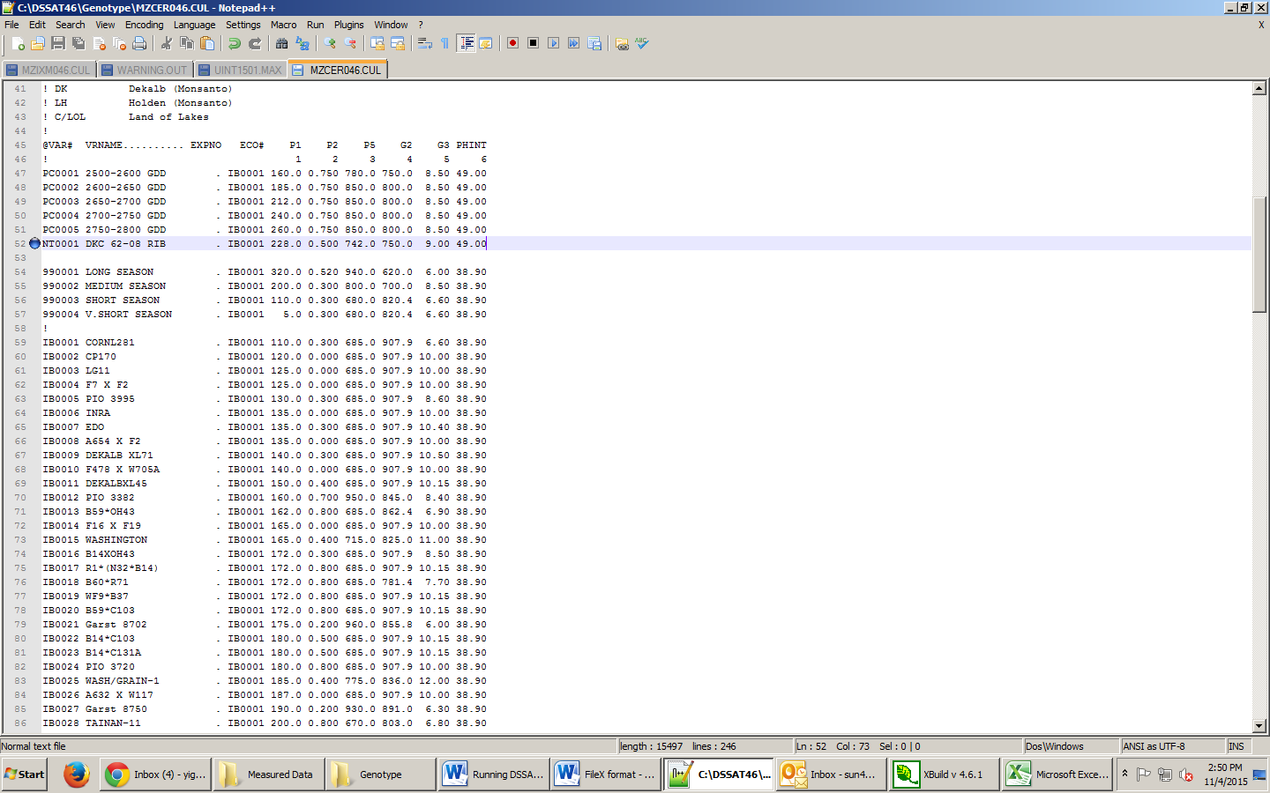

The coefficients calculated above could be not accurate enough, we may need to develop a new method to calibrate these coefficients.

The ranges of the genotype parameters are:

**Minimum Maximum**

MZ_P1 5 450

MZ_P2 0 2

MZ_P5 580 999

MZ_G2 248 990

MZ_G3 5 16.5

MZ_PHINT 49 49

**Run the simulation:**

* Edit file paths in DSSATPRO.L46 (DSSATPRO.V46 or DSSATPRO.FLE??) to point to where the DSSAT folder is located
* Navigate to the folder: C:\DSSAT46\Maize
* On the command line: C:\DSSAT46\DSCSM046.EXE MZCER046 A UICP1501.MZX

Where UICP1501.MZX is the FileX name. If a different name is used, then it should be replaced with the new name.

**Output file:**

The simulation results will be in an ASCII file with the same name as the FileX but with an extension name of .OSN, i.e. UICP1501.OSN. See “h([\\swsrsetserver](\\\\swsrsetserver))\N Tracking Project\Variable Explanations in Soil Inorganic Nitrogen Daily Output File” for the explanation of all the output variables.

From the output file, we can read out those data of N concentrations, and show them in a table or graph to the user. We only need to show the data from the planting date to the current date. All the data after the current date should be discarded.

**Source code:**

The source code of the DSSAT 4.6 is in h(\\swsrsetserver)\N Tracking Project\dssat-46-source code.